**Declare Index & Property Optimization/Exposing a Property:**

**Page List:**

**In our application we used pagelist properties in Commercial Vehicle section.**

**If we add records in Commercial Vehicle Pagelist, it will save the records in a separate index Table:**

**Property Optimization:**

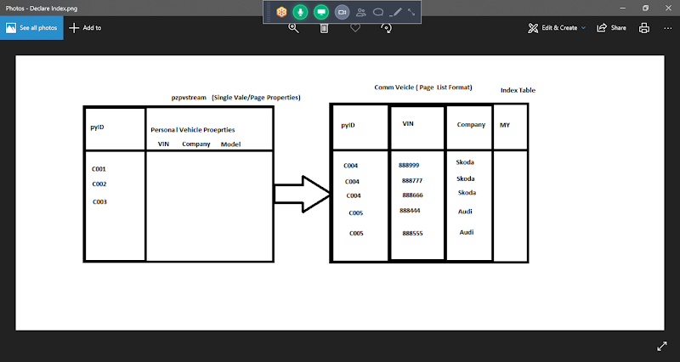

* **It is a technique of creating a new column in the table, copying the blob data in to a new column.**
* **When we optimize single value/page properties columns will be created in the same table.**
* **When we optimize Page List Properties, it will create a separate Index table with same name as Pagelist Class. This table contains all the data of Pagelist.**
* **Each row in the table corresponds to one indexed page of pagelist. That's why this is called as Index Table**
* **Index table will be connected back to a class called Index Class.**
* **Index Classes are derived from Index-**

**Declare Index:**

**Purpose of Declare Index is, Index joins can be done using declare index or Direct reference to the index tables.**

**Declare Index Used to Fetch Page List Data from the Index Table.**

* **Each row in the table corresponds to one indexed page of pagelist. That's why this is called as Index Table**
* **Index table will be connected back to a class called Index Class.**
* **Index Classes are derived from Index-**

**-  It will also create Declare Index Rule which will define the relation b/w PageList Context Class & Index Class.**

**- To Fetch Data From Index Tables we have to Perform Index Joins. Index Joins can be done using Report Definition Rule.**

**Working with Declare Index & Optimization:**

**Req: Create a report Definition to fetch all the Commercial Vehicle list of Different Work objects.**

**First Add Work Object data & submit for Commercial Vehicle form.**

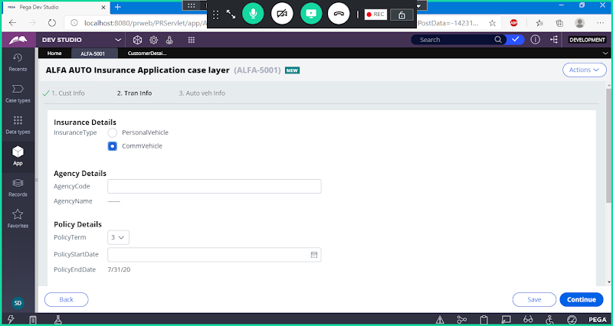

**Add Few Records & Finish**

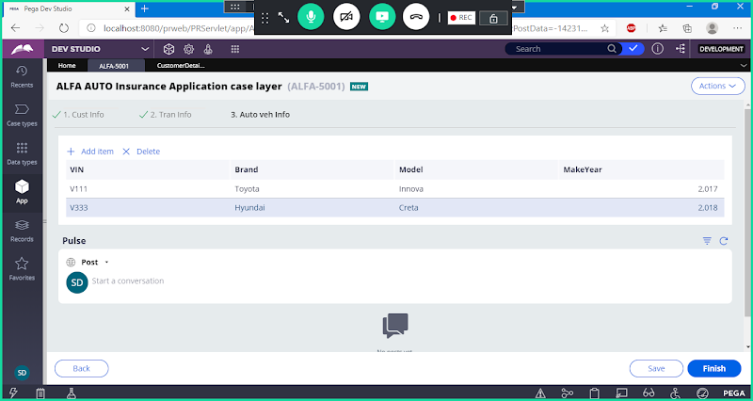

**Click on Finish**

**-----**

**Commercial Vehicle is a Page list Property:**

**Optimize each Property under Pagelist separately.**

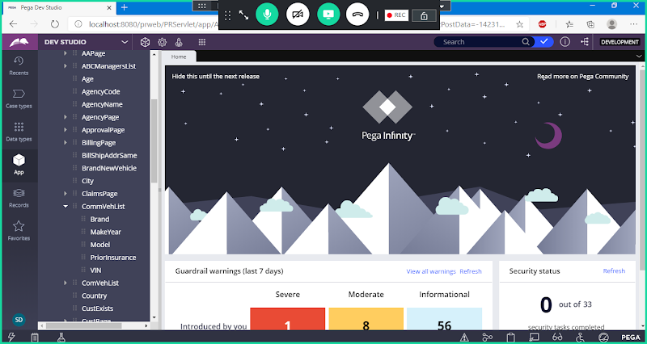

**First Optimize VIN Property:**

**Right Click on VIN**

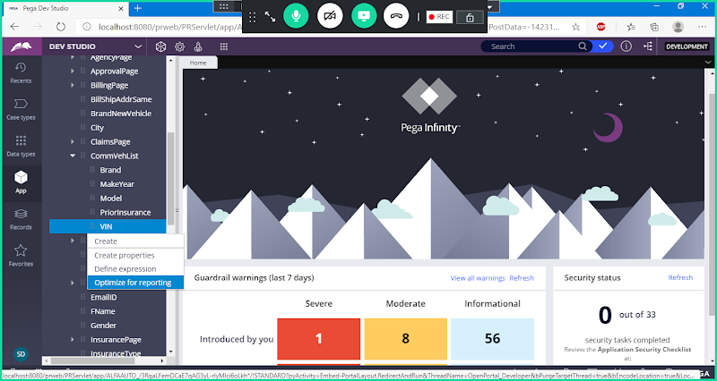

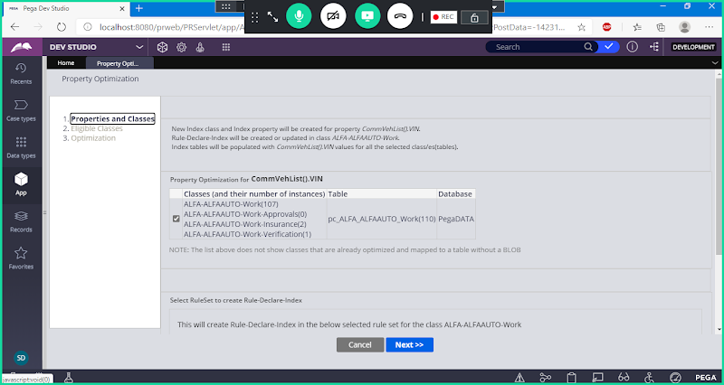

**Provide Ruleset Name & Version**

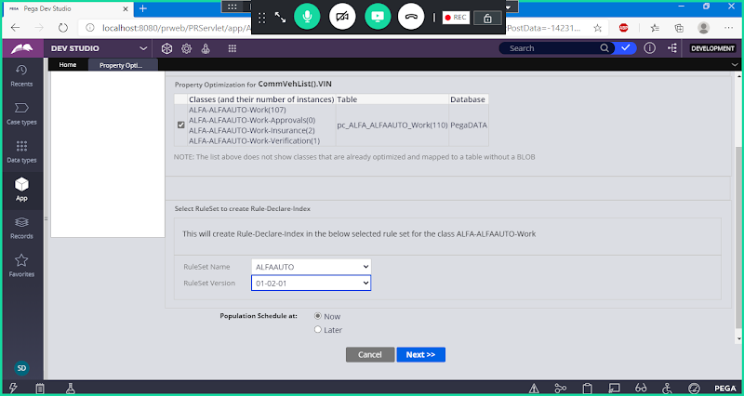

**Next**

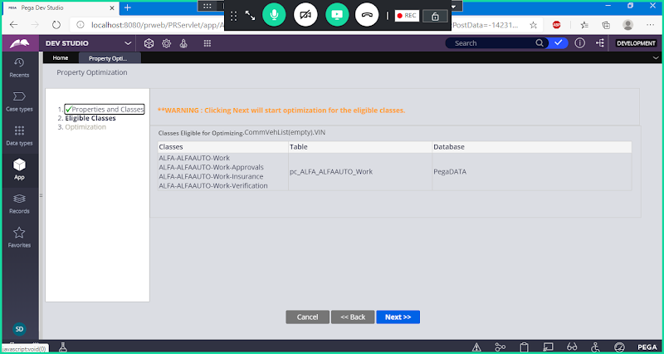

**Next**

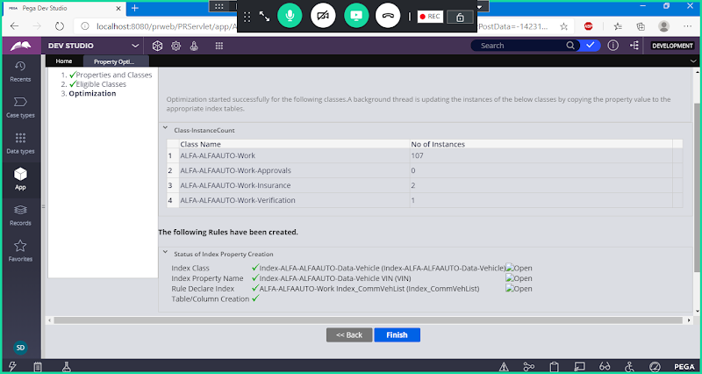

**Click on Finish**

**Similarly Optimize other Properties ( Brand, Model, MakeYear)**

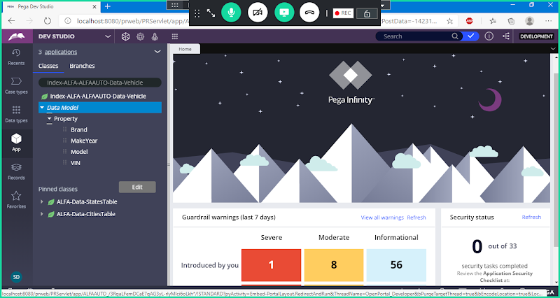

**=**

**Create Report Definition Rule under Work Class:**

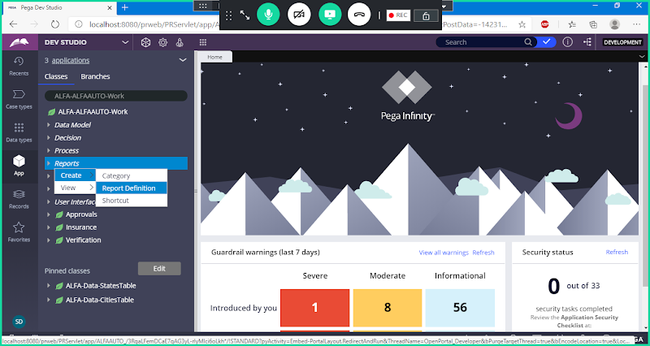

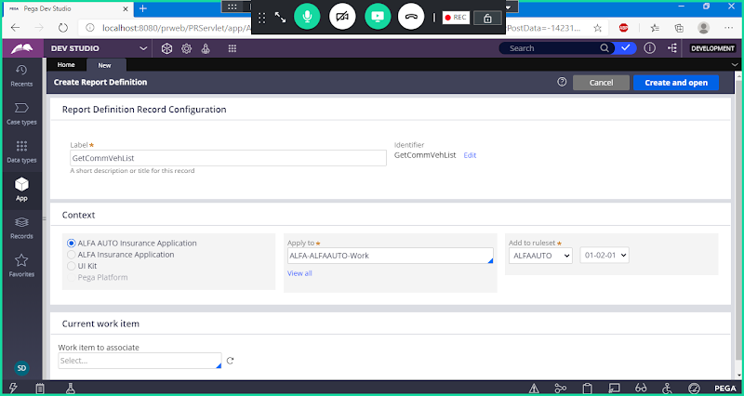

**Open & Go to Data Access Tab:**

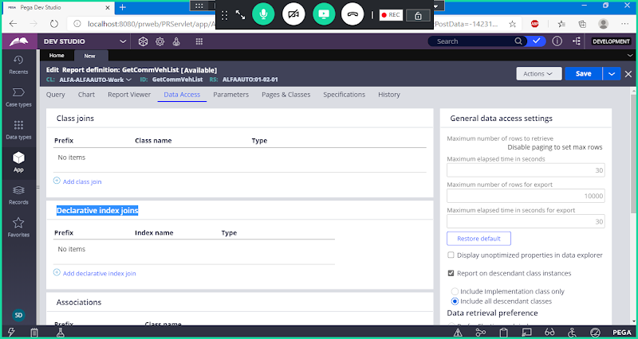

**Click on Add Declarative Index Join**

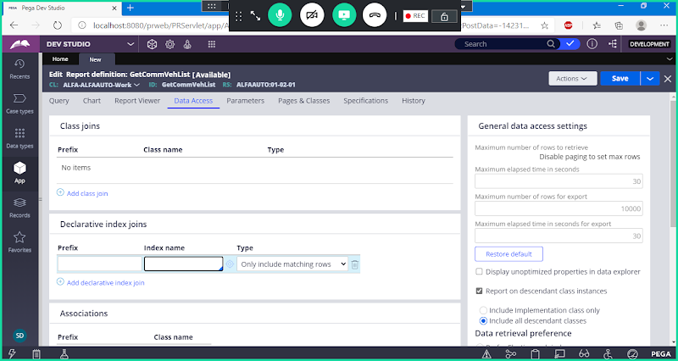

**Click on Add Declare Index Join**

**Select Index Name in the Drop Down**

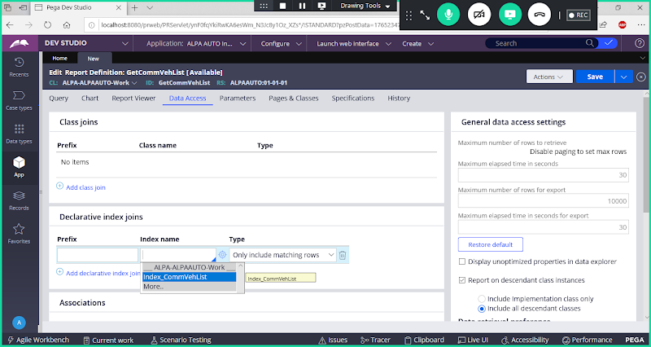

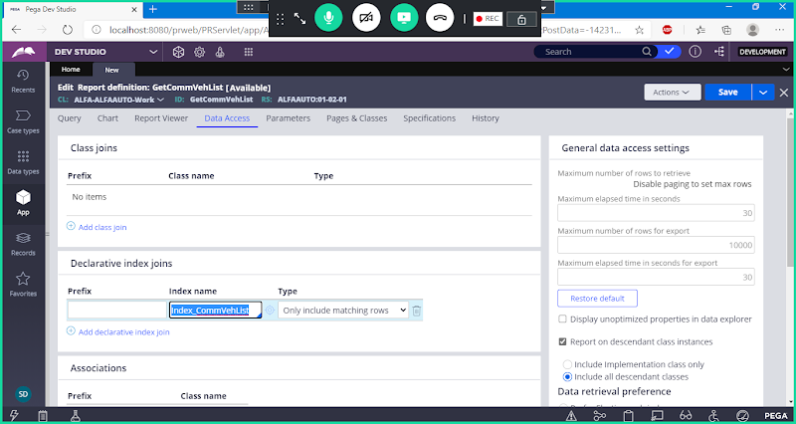

**Copy Index Name in Prefix Also**

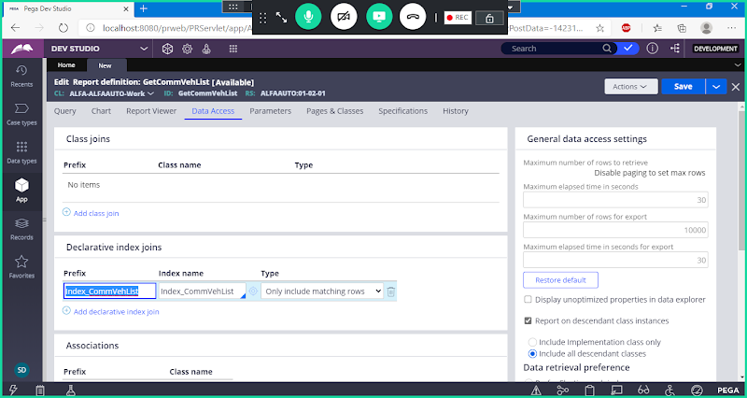

**Go to Pages & Classes**

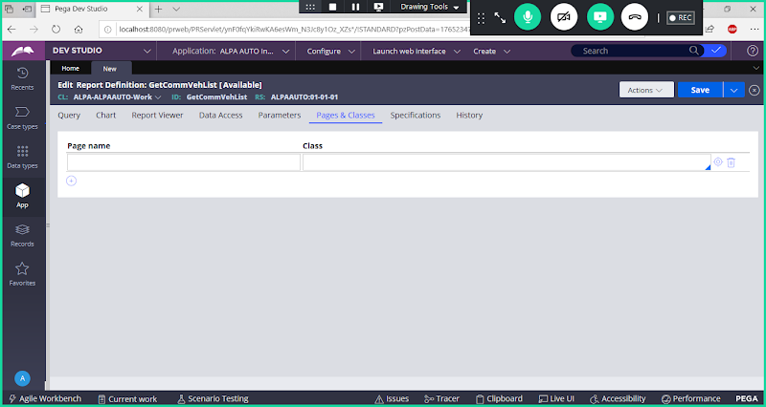

**Add Index Page Name & Index Class Name:**

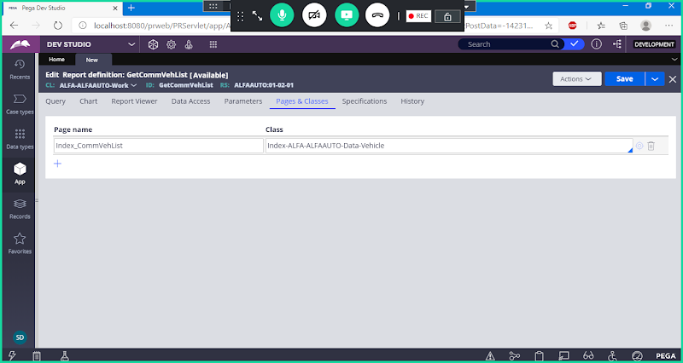

**Go to query tab:**

**Add Index Properties & pyid**

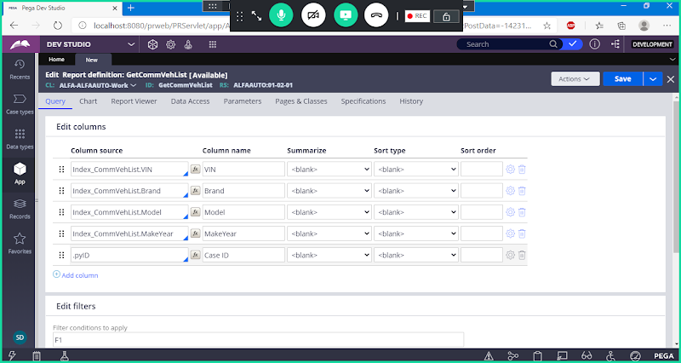

**Save Report Definition**

**Run the Report to Verify the Data:**



